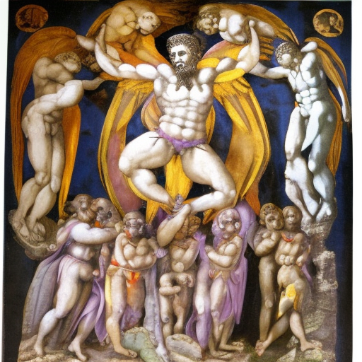
MEMORY BANK OF SISYPHUS

Michelangelo’s gnosis descends into
St. Clement’s Alexandrian Protrepticus
Mahakala’s dark flames of suspended disbelief
Breakthrough blessings of frankincense and myrrh
A wrestling with intellect’s accursed accuser
The magnificence of the little death
Strategic conquerors claiming flags and narratives
Humility before altars of revelation
Getting all thoughts here: Erased, Restored, Ever Recollected
Monumental storehouses for the betterment of generations

